Benny Iko

7/5/2021

SWEN 603 9040 Modern Software Methodologies

Lean methodology critique

Lean software development, adapted from Toyota, is a methodology that combines IT principles/practices and lean manufacturing. The primary focus of lean is to identify and eliminate waste from the process with respect to maximizing customer value. This focal point separates this method from other Agile methods. Also, it is easily distinguished by the other six development principles which promote speed, exploration and efficiency; amplifying learning, empowering the team, building integrity in, seeing the whole, delivering as late as possible, and deciding as late as possible.

Lean methodology, as the name implies, eliminates bloat and focuses on essentials, resulting in many benefits. In order to aid software development efforts and to identify and eliminate waste easier, the seven wastes of manufacturing were translated into the seven wastes of software development. Lean software management looks to remove partially done work, extra features, extra processes, task switching, waiting, motion, and defects. Waiting is one of the biggest wastes in software development; namely waiting for things to happen, such as a delay in a project, testing or deployment. These wastes happen and exist in most organizations; what makes this method so desirable is the amount of effort dedicated to waste management in comparison to Waterfall or other Agile methods. Other methods introduce solutions to the aforementioned problems, but from what I can recollect, Lean is the only method seeking to actively eliminate this waste. Anything that does not directly add value to the end-user is considered waste. Also, I find that the other principles are closely related to the concept of waste as well. For example, removing waste in unnecessary bottlenecks is a sure fire way to empower teams. Implementation of the Lean methodology provides autonomy; teams are better able to focus on the problem. For instance, if we look at the Work-Out technique found in Lean, roles are reversed and managers are taught
how to listen to developers. This results in a developer’s improved ability to explain potential actions to be taken, as well as provide
suggestions for improvements. This value falls in line with that of other Agile methodologies, where the idea is to let senior developers do their job. In turn, project managers focus on removing impediments in the process instead of micro management. Software is designed to solve complex problems, as a result, Lean systems emphasize “seeing the whole.” Since development of large scale IT projects usually involves many moving parts, Lean software development accounts for this difficulty through examination of the problem using root-cause analyses. One simple approach is called The 5 Whys, seen below. Used to investigate cause-and-effect relationships underlying a precise problem, the objective of this method is to determine the root cause through repetition of the question “Why?”

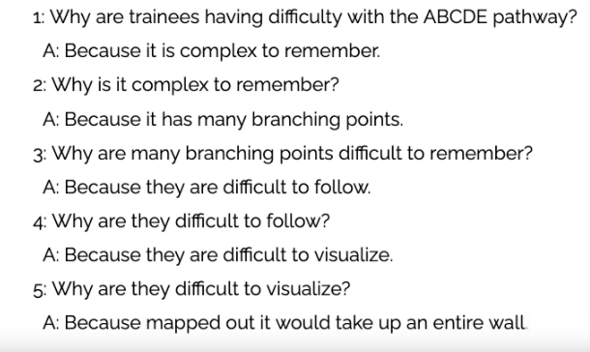
Root-cause analysis for development of user-centered mobile app

The careful attention to detail exhibited through use of the 5 Whys is the epitome of integrity being built in. In the software engineering field, integrity is defined as freedom from defect, flaw, or decay. Integrity is obtained through excellent detailed information flow; from users to the development team and between development team members. Lean shares this concept of flow found in continuous software engineering. Another factor in achieving system integrity is the decision to wait as late as possible. Delayed decisions are valuable due to the fact that they can be made based on facts instead of speculation. Development practices like Lean that provide for late decision making are effective in domains with some degree of uncertainty, such as software engineering because they provide an option-based approach.

Lean principles can guide the practice of agile software development. There are many motivations to adopt this form of product/project management. I would use Lean methodology for projects that I create, because of my desire to complete software quickly without defects. According to Modern Software Methodologies, “the best approach for improving a software development environment is to amplify learning.” This principle, along with the fact that I greatly value the concept of trying new ideas, and writing code over documentation is why I would want to use this project management style. Specifically, Lean project management has a proven track record, gaining broader acceptance in healthcare administration and global health communities. There are articles suggesting that Lean strategies applied to software development for global health initiatives, particularly for low- and middle-income countries, may address previous concerns regarding prior limitations.

Lean software development is effective at removing unclear requirements and increasing the rate of internal communication. The quote "think big, act small, fail fast; learn rapidly" sums up the explorative nature of the process, as well as the inherent speed involved. Adapted from the Toyota production system, this methodology features lean manufacturing and IT principles and practices translated to the software development domain. Through successive iterations of elimination of waste, amplification of learning, team empowerment, built-in integrity, seeing the whole, delivering as late as possible, and deciding as late as possible computer software is generated.

